4th grade math test

Name ________________ Date: _____________________
Solve the following problems
1.
a. Which fraction is not equivalent to the other two? ___________
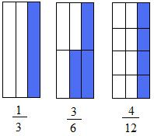Equivalent fractions
2. Jester has a business that is not doing well. On Friday, he earned 468 dollars. On Saturday, he earned 459. On Tuesday, he earned 432 dollars. How much money did he earned on Thursday?
A. 424 B. 414 C. 314 D. 451
3. Look at the base-10 blocks below and tell which number it represents. Take a close look before answering!
Base 10 blocks
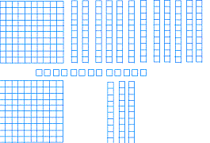
A.363 B. 164 C. 451 D. 300
4. Round 846 to the nearest hundred _____________ and 3756 to the nearest thousand _____________
5. What number is the same as five thousand twenty-two?
A. 5200 B. 502 C. 5202 D. 5022
6. Write the decimal 0.25 and 0.4 in words and as fractions
0.25 : ___________________________________________ ______________
0.4 : ___________________________________________ ______________
7. Which number is greater than 5678 but less than 5708?
A.5677 B. 5707 C. 5800 D. 0
8. What is the value of the symbol # ?________________
6 + # = 14
9. How many blocks of 100 and 10 can you make with 3250?
A.325 and 1 B. 32 and 5 C. 30 and 50 D. 3 and 55
10. 1 quarter, 3 dimes, 2 nickels, and 6 cents equals
A. $0.70 B. $0.71 C. $0.75 D. $0.69
11. Multiply 235 by 13 ________________
A. 4322 B. 3078 C. 3055 D. 566
12. Which fraction is greater than 2/3?
A. 1/3 B. 4/5 C. 4/6 D. 2/6
13. The shaded fraction is
A. two-ninths B. nine-three C. four-eights D. Three-ninths
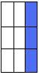
Three-ninths
14. Perform the following additions and subtractions
64837 + 4598 = ?
92345 - 91422 = ?
15. What is the best name of a geometric figure that looks like a dumpster? ______________________
Which of the following shape could you probably use to describe the shape of your eyeball?
A. Cube B. Sphere C. Cylinder D. Cone
Which of the following shape could you probably use to describe the shape of the refrigerator in your house?
A .Cube B. Sphere C. Cylinder D. rectangular prism
16.Suppose you have 3 quarters, 5 dimes, 2 pennies, and 1 nickel in your pocket. You tell a friend to pick only one coin. Which coin is your friend most likely to pick? Briefly explain why
17. Write the following numbers in words
5669 ___________________________________________
8765 ___________________________________________
18. Perform the following long division
19. Which two circles when added will give you a whole?
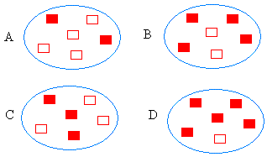
Model of fractions
Choice #1: A and C Choice #2: B and C Choice #3: A and B Choice #4: B and D
20. Make a circle. Break the circle into 4 equal pieces. Then, shade two-fourths of the circle.
21. Make two circles. Break both circles into 4 equal pieces. Then, shade three-fourths of the first circle and one-fourth of the second circle
a. What is three-fourths minus one-fourth? _______________________
b. What is three-fourths plus one-fourth?_________________________
21. Which math problem(s) means the same thing as 40 + (100 + 300)? ______________
A. 140 + 300 B. 40 + 500 C. 40 × 11 D. 40 ×100 + ( 30 )
22. Problem solving skills.
You 6700 dollars in your pocket. You want to buy 7 laptop costing each 800 dollars.
How much will the 7 laptops cost?_________
22. If 5 books cost 100 dollars, what is the price of 2 books? (Suppose you bought 5 of the same book)
23.The area of the shape below is
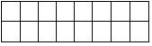
A. 14 square units B. 17 square units C. 10 square units × 11 D. 16 square units
24. In the space below, draw 2 lines that are parallel and a third line that is perpendicular to the parallel lines

